12 Assigning Custom Favorites
Honestly, it is much easer to do this then to give it a shortcut key, as the list of shortcut keys that Blender uses is extensive, and anything you can probably think of is already taken.
Select the tool you want to assign a shortcut to.
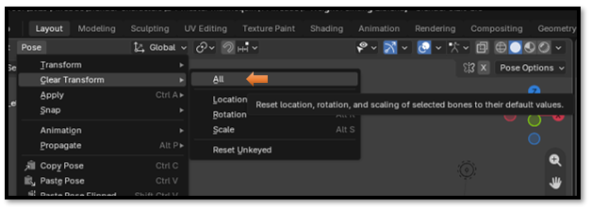
Right click on it, and either select Add to Quick Favorites.
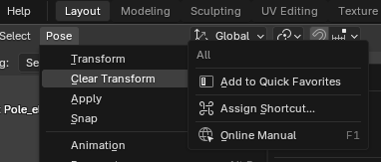

To Access Quick Menu, press Q on your keyboard. If you select the All that comes in the list first. It is like selecting all the bones first, and then clearing the pose all in one step. That is great.
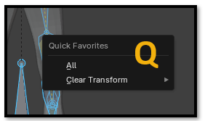

Find the command → Right-click → Add to Quick Favorites → press Q whenever you need it.

